Họ và tên: Lê Bá Khánh Trình

MSSV: 6151071108

Lớp: CNTT K61

**(4) Oracle Queries: where statement**

1. Write a Oracle SQL query to get the employee no, first name and last name for those employees who are earning commission. 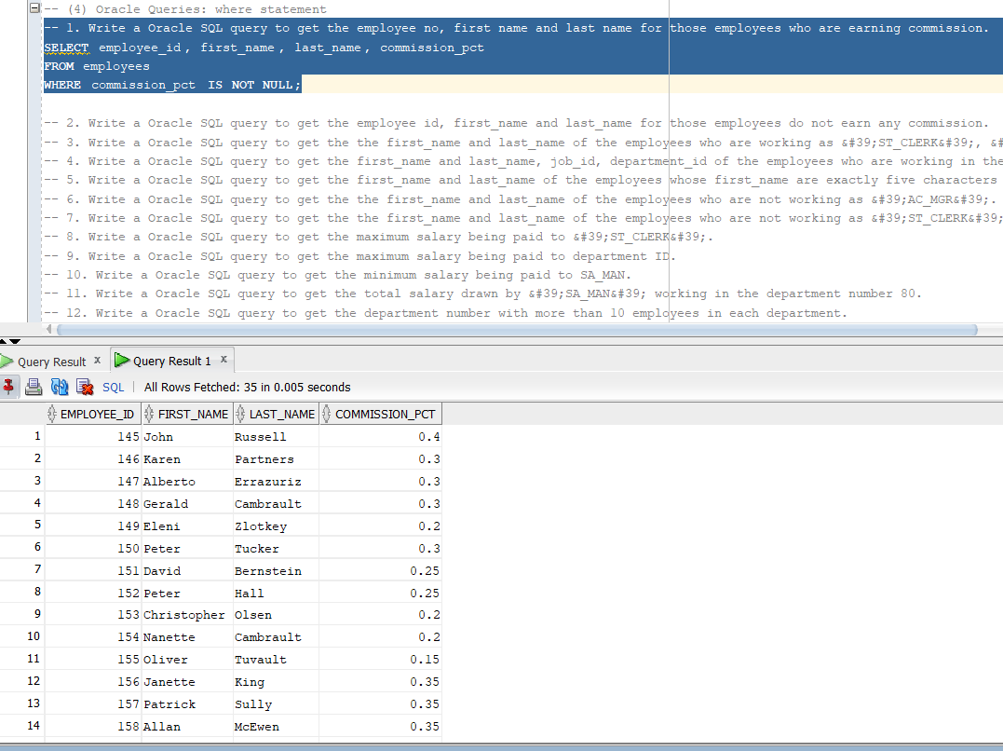

2. Write a Oracle SQL query to get the employee id, first_name and last_name for those employees do not earn any commission. 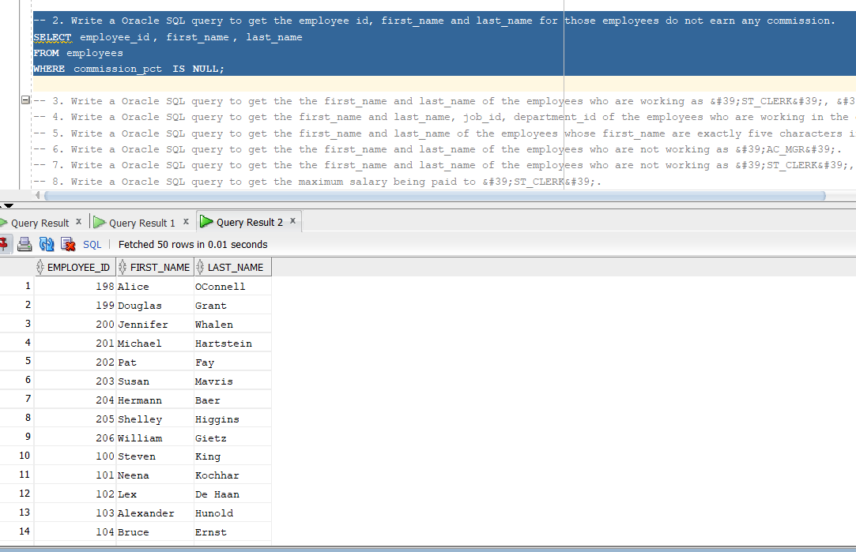

3. Write a Oracle SQL query to get the the first_name and last_name of the employees who are working as &#39;ST_CLERK&#39;, &#39;SA_MAN&#39; or &#39;IT_PROG&#39; and drawing a salary more than 3000. 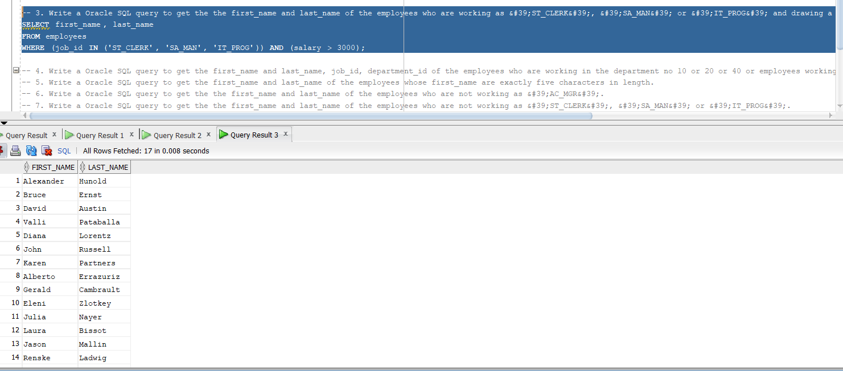

4. Write a Oracle SQL query to get the first_name and last_name, job_id, department_id of the employees who are working in the department no 10 or 20 or 40 or employees working as &#39;ST_CLERK&#39;, &#39;SA_MAN&#39; or &#39;IT_PROG&#39;. 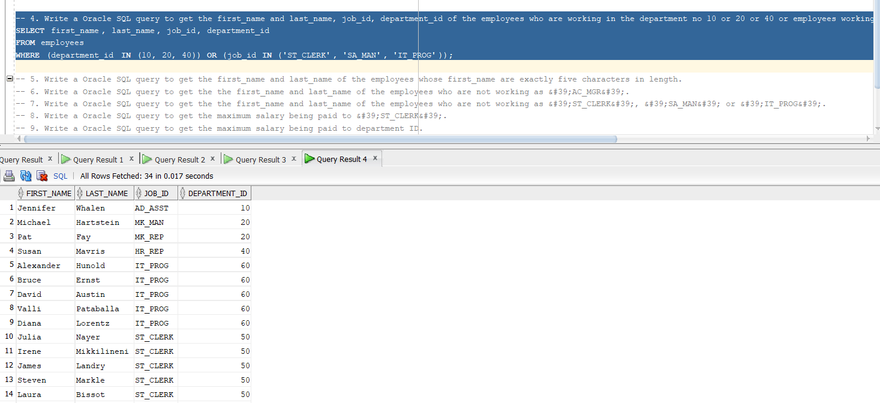

5. Write a Oracle SQL query to get the first_name and last_name of the employees whose first_name are exactly five characters in length. 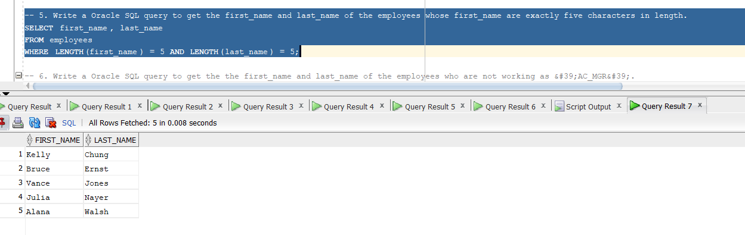

6. Write a Oracle SQL query to get the the first_name and last_name of the employees who are not working as &#39;AC_MGR&#39;. 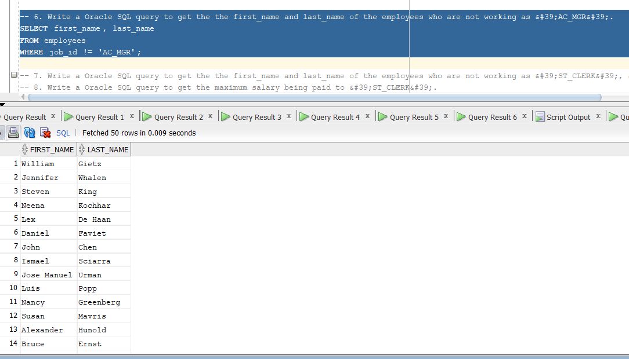

7. Write a Oracle SQL query to get the the first_name and last_name of the employees who are not working as &#39;ST_CLERK&#39;, &#39;SA_MAN&#39; or &#39;IT_PROG&#39;.

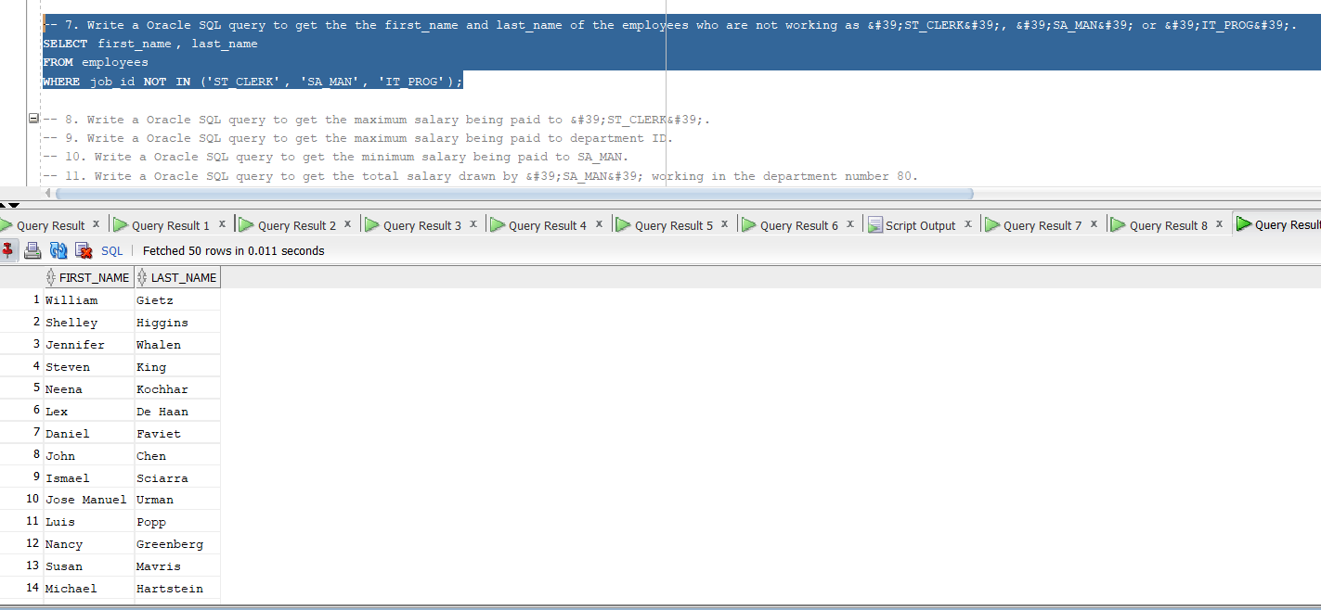

8. Write a Oracle SQL query to get the maximum salary being paid to &#39;ST_CLERK&#39;. 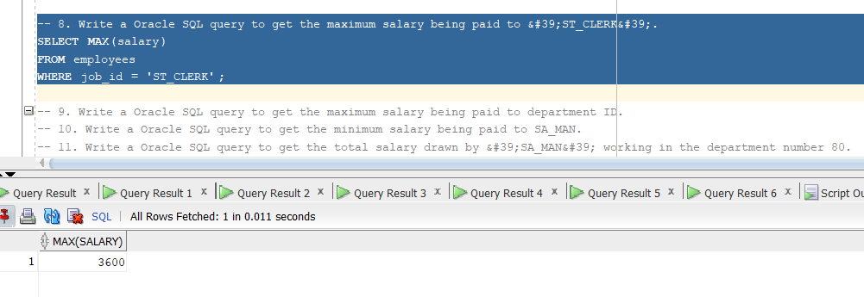

9. Write a Oracle SQL query to get the maximum salary being paid to department ID. 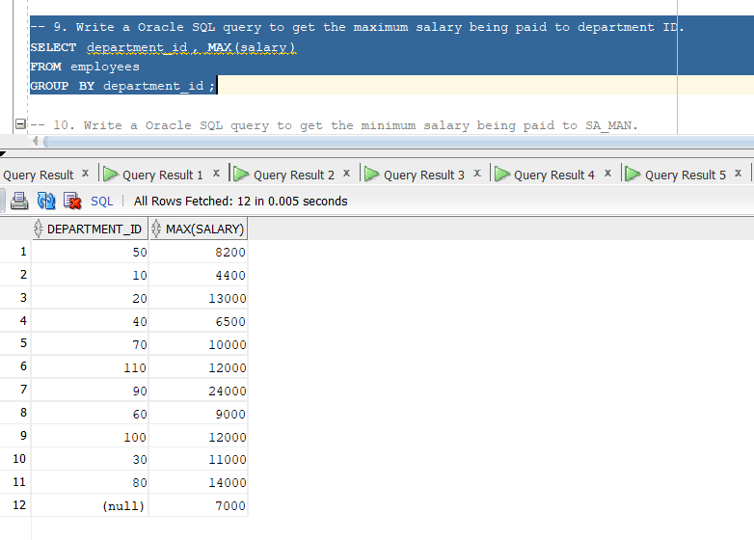

10. Write a Oracle SQL query to get the minimum salary being paid to SA_MAN. 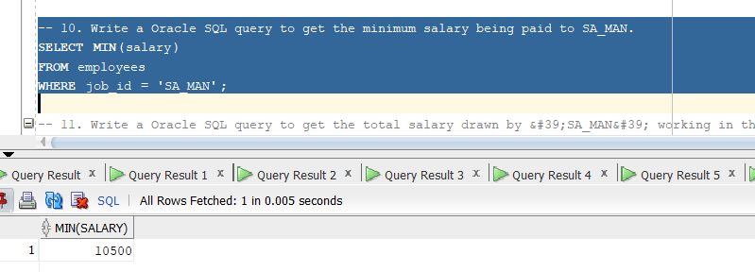

11. Write a Oracle SQL query to get the total salary drawn by &#39;SA_MAN&#39; working in the department number 80. 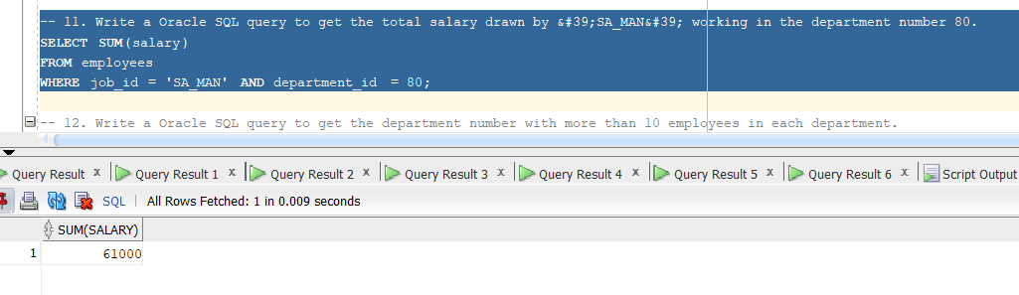

12. Write a Oracle SQL query to get the department number with more than 10 employees in each department. 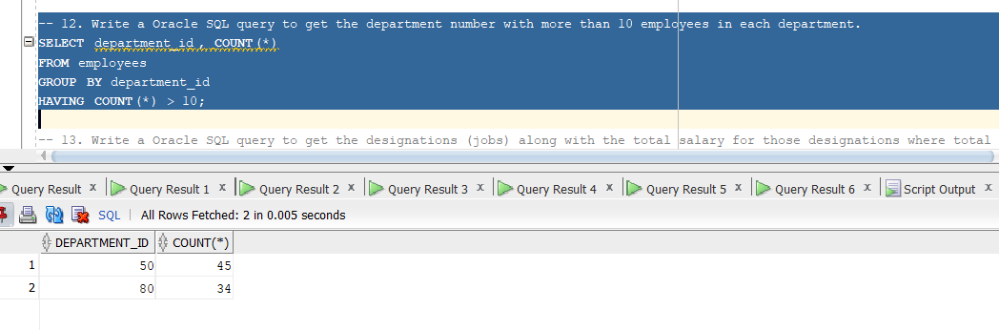

13. Write a Oracle SQL query to get the designations (jobs) along with the total salary for those designations where total salary is more than 50000. 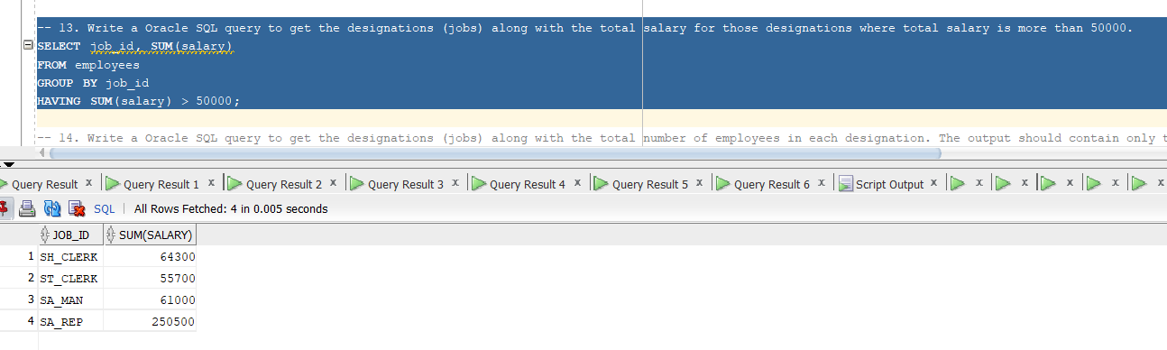

14. Write a Oracle SQL query to get the designations (jobs) along with the total number of employees in each designation. The output should contain only those jobs with more than three employees. 